** Legacy College of Compostela**

Dagohoy Street, Compostela, Davao de Oro, Region XI

legacycollege.comp.reg@gmail.com

**EMPLOYEE’S PAYROLL MANAGEMNENT SYSTEM**

**_____________________________________________________________**

A system proposal presented to the faculty

of Information Technology Education

in Legacy College of Compostela

**____________________________________________________**

In Partial Fulfillment of the Requirements

for the Degree of Bachelor of Science in

Information Technology

**____________________________________________________**

Proponents:

Stephen Cagape

Kert Lloyd Dionola

Don Reymon Mendoza

September 2022

**TABLE OF CONTENTS**

**Title Page i**

**Table of Contents ii**

**Chapter 1 – Introduction Page**

* 1. **Background of the Study 1-2**

* 1. **Statement of the Problem 3**
  2. **Objectives of the Study 4**
  3. **Significant of the Study 5**
  4. **Scope and Limitation 6**
  5. **Definition of Terms 7**

**Chapter 2 - Review of related literature and Studies Page**

**2.1 Related Literature 8-9**

**2.2 Related Studies 10-11**

**2.3 Reference 12-13**

**Chapter 3 – Prototype Design**

**3.1 Data Flow Diagram 14  
3.2 Conceptual Frameworks 15  
3.3 Entity Relationship Diagram 16  
3.4 Log-in Form for Admin  
3.5 Register Interface  
3.6 Main Form Interface  
3.7 Interface of Adding Employee  
3.8 Upload Picture  
3.9 List of Added Employee  
4.0 Interface of Update Employee  
4.1 Interface of Attendance  
4.2 Shows the Payroll per Employee  
4.3 Generate Payslip  
4.4 Payslip  
4.5 Payroll Reports  
4.6 Staff Log-in  
4.7 Staff Dashboard  
4.8 Staff can View Attendance  
4.9 Staff can Generate Payroll  
5.0 Staff can Generate Payslip  
5.1 Printed Payslip  
5.2 Staff can view Payroll Reports  
5.3 Printed Payroll Reports**

**i**

**ii**

**CHAPTER 1**

1. **INTRODUCTION**

Payroll consists of the process by which a business pays its employees for work performed during a specific period. A payroll system allows businesses to follow a set series of processes in order to make timely, correct payments in compliance with government regulations. A payroll system may be manual or computerized and handled in-house or outsourced to another provider. John DuBois, (2016). An Introduction to Payroll Systems.

The payroll process typically includes calculating employee pay, recording payroll transactions and determining and paying payroll taxes. A company must have in place a timekeeping system that accurately reflects the hours put in by nonexempt employees as well as the regular salary payments for exempt workers. Employers typically withhold federal income tax from employee earnings; at the end of the year, they must report all wages, tips and other compensation paid. Companies also must withhold Social Security and Medicare contributions from employee’s wages and pay a matching amount. John DuBois, (2016).Payroll Process Overview.

**1**

**1.1 Background of the Study**

The manual system is not efficient and reliable and would like to have an automated computer system for managing employee’s attendance. Using MS Excel/spreadsheet in processing payroll, efforts and time spent is considered. Hence, if this process is automated, it shall be of great help to not just minimize the consumption of time in preparing or processing the payroll but also, avoiding errors.

Globally, in India payroll is a critical operation for every organization to accurately pay employees' salaries and enrollments. On the schedule taking control of employees' pay calculations is a time-consuming and labor-intensive task if done manually. Larger organizations require more effort and time. As a result, automating this process would be extremely beneficial because it would take less time to calculate the salaries of the employees. This paper provides a solution in the form of software for payroll management system service on the cloud. This system allows multiple users to access data. Each user, such as an employee, HR representative, or administrator, can access the software by entering the username and password assigned to them by the company. It involves keeping track of hours worked and is capable of keeping a record of employee data every month, including their pay, allowances, deductions, and taxes so that new definitions can be created.

The Department of Health (DOH) the Philippines employs a Computerized Payroll System, which is a window-based program designed to facilitate and simplify the monthly preparation of general payroll and related reports. It is a computerized payroll system that is used in all DOH offices. The system allows for faster and more accurate computation of monthly gross income, deductions, and net salary, as well as faster and less resource-intensive generation of General Payroll and other payroll-related reports, as well as payroll data and information security and integrity (DOH Information Management Service, 2009).

**2**

The Legacy College of Compostela, located in Compostela, Davao de Oro is a private institution that is currently utilizing the manual tradition in processing all the transactions for employees which causes time consumption in processing the payroll of employees. Proponents proposed the Employee’s Payroll Management System to keep track of all records of employee. The System also promotes better security and helps keep employee data confidential.

**3**

**1.2 Statement of the Problem**

**General Problem:**

Every employee of a business who receives a regular salary or other form of compensation is included in the payroll. The research "Employee's Payroll Management System" addresses the main issue of Legacy College of Compostela with regards to replacing the manual payroll with an employee's payroll management system that would give them a simple method of managing payroll in the institution.

**Specific Problem:**

1. **Time Consuming in preparation of payroll reports.**

The preparation of the payroll reports consume a lot of time. The lates and under-time deductions of employee are manually encoded by the HR alone. Time consuming in double checking the reports because of separate computation of salary of contractual and permanent employees.

A huge waste of time in battling with formulas: People using excel for payroll related work tend to invest a tremendous amount of time in adding rows and for rules and formulas. Just one misplaced click and everything goes away. It gives nothing but repeated work.

1. **Overlooking Payroll Information while processing.**

Making payroll reports is a huge task and there are many error that occur and there are some time that you will overlook some of the information. In Legacy college of Compostela Employees Payroll are manually encoded by the HR alone that takes a lot of time and there are some cases of overlooking some information.

1. **Processing Inaccurate Information.**

It is normal for any human to make errors while handling many files, which should be avoided. All the payrolls will overburden you, causing you to make mistakes. You will have to look after the business and the payrolls. It can cause various problems, like untimely payments and wrong payments. This can cause turmoil in your company, and this will spoil the image of your company. If the employees do not get their payrolls in time, they might even threaten to leave.

**4**

**1.3 Objectives of the Study**

This study aims to develop the employee’s payroll management system for Legacy College of Compostela. Specifically, this study has the following objectives:

* To develop a system that will automatically compute and reflect gross income.
* To develop a system that will avoid any overlooking of the payroll information.
* To develop a system that will speed up the generation of payroll by linking biometric device in the school to the system that will avoid inaccurate processing of information.

**5**

**1.3 Significance of the Study**

This system is expected to be user-friendly and will be helpful to the human resources department in boosting the processing of payroll and lessen the errors in calculating the deduction of the employee’s benefits. The Employee’s Payroll Management System will be developed to provide information to employees. Automating payroll saves a tremendous amount of time and effort over a manual process, as well as reduces the likelihood of errors. The following will be the beneficiaries of the proposed system.

**Human Resources Department**

Human resources (HR) can improve the quality of reports. It helps the HR person in charge to reduce difficulties in processing the employee's deductions and salaries. It reduces the chance that an overworked human resource (HR) employee will make a mistake with an employee's wage calculation or that a piece of employee data will get improperly entered.

**Employee**

The Salary gets generated on time, also the deductions and overtime generate quicker.

**School**

The school can prepare staff and employee’s payslip anytime with ease, and also saves enormous time.

**Future Researchers**

Future researchers and the proponents will gain knowledge about the existing system in the administrative office, and with this: skills in the system analysis will be improved; it helps the future researcher to have an idea about payroll system, and develop their own system. They can learn about the proponents system and at the same time develop a greater system with the help of the proponent study.

**6**

**1.4 Scope and Limitations**

**Scope**

The Employee’s Payroll Management System is an automated way to speed up the calculating deductions and any payroll management processes worked by Human Resource for employee’s salaries. The system will have features that will keep and retrieve data in the database. The system can search the ID number of each employee to find the employee’s payroll report easily. The system can add employees, update and delete employee’s data information. The employee can access the system only to view his/her personal information. Timely reports will automatically generate bio-metrically and can be used for performance appraisals. The system will automatically calculate the payroll for each employee based on the attendance performed. It covers the time-in and time-out of employees through bio-metrics, specifically through a fingerprint scanner technology.

**Limitations**

The proposed system will only be used for payroll transactions by the Legacy College of Compostela. It is applied as a stand-alone concept where online transactions are not part of the system features.

**7**

**1.5 Definition of terms**

This section gives a definition and explanation of some of the terms used in the project:

**Conceptual Definition**

**Payroll:** list of a company's employees and the amount of money they are to be paid

**Pay period:** It is the amount of time for which an employee is paid such as hourly, weekly or monthly.

**Loan** –This refers to funds transferred from one party to another as payment purchased goods or services.

**Salary:** It is a fixed annual sum, paid at regular intervals, usually monthly, to an employee, especially for professional and clerical workers.

**Operational Definition**

**Payroll:** It refers to the payroll of employees of Legacy College of Compostela.

**Pay period:** it isEmployees of Legacy College of Compostela will get paid twice a month

**Salary:** It is the amount of money alloted to every employee as per offered by an institution according to the job description to which is given every 15 days.

**8**

**CHAPTER 2**

**Review of Related Literature and Studies**

This section tells all the readers what are the related features of the system proposed to the other system of the foreign and local companies. This section also tells what are the possible theories, concepts, or principles to support the investigation and presents various related literature and studies which are relevant in the conduct and development of the project entitled Employee’s Payroll Management System.

**2.1 Review of Related Literature**

**Krizalen Enterprise Payroll with Biometric System**

According to Alvarez, Aldrine, Gecolea (2014) uses biometrics with online data analytics dashboard to give Krizalen enterprises an efficient payroll system that can automatically monitor the attendance and trip tickets of the employees, drivers and helpers with the biometric technology and data analytics that would help them in the security and accuracy of the company payroll and information. Summing up the past situation of payroll inside Krizalen enterprises, there was a need for a system that could help them with employee information management attendance, monitoring, payroll processes, and assistance for the manager decision making. With this idea, the proponents conducted a study for the development of software that can minimize data redundancy, inconsistency, and manipulation. Employees can view their current pay and review their information from the database. And with updating of the reports that can be viewed through the internet, the manager can view the recent activities within the proposed system.

**9**

According to Kawale et al. (2018) one of the most difficult operations for every organization is payroll, organization must pay employee correctly and accurately on time. Error free payroll processing need to be attain by organization. As the times go by the needs of an organization grow, therefore, the responsibilities and operational.

works are also grown. Vanessa PDF In an association there are a few offices and every division has payroll area to oversee finance exercises. Each part needs to perform vital tasks like information assortment and planning. passage, refreshes observing and announcing of information. Large numbers of these current practices and methodology should be reevaluated during this season of evolving needs, evolving requests of representatives and changing innovation so an association needs a finance framework that would deal with the staff and finance related subtleties, preparing in every division and finance review in a more proficient way. With this finance framework, finance segment would have the option to track workers including their faculty information, pay slips, remittances, allowances, leave and so on. Kawale et al. (2018) mentioned that "Unified Modelling Language (UML) diagrams are useful approaches. Through UML diagram flow of a system, the interaction of a user with the system can be described in an efficient way."

**Automated Payroll System of Pamana Medical Centre**

According to the researchers Aguilera Bronzas and Marqueses (2010) a great payroll is really one of the most important issues to pay attention in almost every company. It is impossible to handle payroll responsibilities with a pen, ledger sheet and calculator, but nowadays it is more convenient for most companies to use computerized payroll software.

According to the book "System Documentation" (2010), states that “a computerized payroll system must have the ability to update and maintain employee information and to generate required outputs including paychecks, reports to management and to the government.”

According to a blogged article in blastasia.com (2007), says that “a computerized payroll system is designed to help human resource professional as well as finance and accounting personnel to manage employee compensation, deductions, allowances, and benefits in an organization.”

**10**

**2.2 Related Studies**

**Nyanmaru Computerized Payroll System**

According to the researcher of Nyanmaru Computerized Payroll System (2013), nowadays all establishment are becoming modernized, they use modern technologies to make their transaction fast, easy and accurate in order to avoid waste of time and for the sake of safety and security. It also helps human to solve and understand complex problem and analysis such us the computational need of humans. Especially to business establishment or corporation processing enormous data complex transaction ([www.scrbd.com](https://l.messenger.com/l.php?u=http://www.scrbd.com/&h=AT2_UCo4iChM7b9-tJJ1wddYZGJHvk9Vh1c1SZ4o7UhBwZ_6iRbCHOT_LKjDjF2BtajS0Ds7TLWYxzW928_9q5da6hnObsVfxkm_I3E2ssKjnZYaXXuSGrSQGwUdmRpfub42Rg)).

**Employee Payroll System**

According to Aishwarya Gupta (2013), AMITY University UTTAR Pradesh that develop a system entitled with employee Payroll System is an application that enables users to create Republic of the Philippines and store employee’s records. This application is helpful to the organization as it maintain data of employee’s related to that organization. Java is used to create this application as it is a platform independent language and can be used on a standalone machine as well as on a distributed network. Furthermore applications developed in java can be extended to the Internet based application. Thus java was chosen to do the front end task to design this application. That insisted the benefits of the application easy calculations.

**Attendance Monitoring and Payroll System with Biometric and SMS**

According to Glenda Manahan (December 13, 2013), to develop an Attendance Monitoring and Payroll System With Biometric and SMS for easy and secured way of monitoring staff attendance, plotting schedules, fast computation of the hours of employees’ work, and computerized payroll system that can help the staff to lessen their work. To computerize the traditional way of monitoring employees’ attendance with time cards. Another purpose for developing this software is to generate the desired reports automatically at the end of every session or in between of the session as they require.

**11**

**Cagayan de Oro City Hall Computerized Payroll System**

According to sunstar.com the City Accounting Department of Cagayan De Oro City has introduced an upgraded computerized payroll system for permanent employees in a bid to improve its services and maximize resources. “This project, which was conceived two years ago, basically aims to improve our services particularly in the processing of payrolls for permanent employees”, City Accountant Wilma Polley-Rugay told payroll in-charge of the different departments and offices at City Hall during a briefing and orientation on the concept of the one-month payroll system held Friday last week at the City Council session hall in Cagayan de Oro City. With the added features of the new computerized payroll system, Rugay said the preparation, processing and payment of payroll system to permanent employees would be hastened and fasttracked ([www.sunstar.com](https://l.messenger.com/l.php?u=http://www.sunstar.com/&h=AT2_UCo4iChM7b9-tJJ1wddYZGJHvk9Vh1c1SZ4o7UhBwZ_6iRbCHOT_LKjDjF2BtajS0Ds7TLWYxzW928_9q5da6hnObsVfxkm_I3E2ssKjnZYaXXuSGrSQGwUdmRpfub42Rg)).

According to the Department of the Interior’s Interior Business Center the Federal Personnel Payroll System (FPPS) is a modern, mainframe-based, portable, integrated, on-line, and real-time personnel and payroll system. The system provides personnel and payroll support to numerous agencies. The system is customer-driven, creating and generating the full life cycle of personnel transactions, enabling agencies to maintain records electronically. FPPS handles all current regulations including specialized pay, garnishments, special appointment programs, and more. FPPS was developed by the Interior Business Center (IBC) using state-of-the-art database technology, fourth-generation language, structured development methodology, and computer-aided software engineering tools for robust performance and ease of maintenance. FPPS is a highly sophisticated and comprehensive database management system providing an extensive array of human resources (HR) and payroll automation support within its core, including requirements prescribed by client agencies, the IBC’s centralized Payroll Operations Division (POD), and the Office of Personnel Management (OPM). The FPPS application supports Requesting Office, Time and Attendance (T&A input), Servicing Personnel Office, Security, Time &Attendance Maintenance, and Pay Maintenance commands for Federal employees and Emergency Workers (Casuals).

**12­**

**2.3 Reference**

K. PHILIP U /2009/BIT/064/D “PAYROLL PROCESSING AND STAFF ATTENDANCE MANAGEMENT SYSTEM CASE STUDY OF KIGUMBA INTENSIVE SECONDARY SCHOOL” From

<https://d1wqtxts1xzle7.cloudfront.net/35048316/Research_Proposal-with-cover-page-v2.pdf?Expires=1639588373&Signature=DyXuSkK56DFf6eV6xB~jMWNeg4T~bR930piexJmCM4dugBY2NoQmghmRa4UYiL3u5IhQsTkmiiI9ntQHq3xRlgRTBajrtI48xFSxOaTbAf6T4MllrPJBU90U1bjIQ3VOinX4JlcQDdd2Hl7h0~JdMNAWPM0nhtqe5hlmdeKBFoAiqvXtTKEGWsJxLW3QcRZXbyTmiEdeT4ExZh9JO-cOpUIOgUbJ8Fh1BnFu6tl4AHyKygLOQpXEuH6bF53GsRxEzhvZn2si4I3Cn2Hx99DQuhJdQb-5~JvUkgq8byPh5HgMrMRmkQ3ddxFc6iRjOyOQYX5r5OyDnviXFw7hOeFVJQ__&Key-Pair-Id=APKAJLOHF5GGSLRBV4ZA>

'

Kritika Mahajan, Shilpa Shukla, Nitasha Soni “A Review of Computerized Payroll System” From

https://ijarcce.com/wp-content/uploads/2015/02/IJARCCE1M.pdf

University of the City of Valenzuela (Pamantasan ng Lungsod ng Valenzuela) “Cagayan de Oro City Hall Computerized Payroll System” From

<https://www.coursehero.com/file/29324569/Chapter-IIdocx/>

Payroll Defination From

<https://www.dictionary.com/browse/payroll>

Manish Singh, Prachi Singh, Rohil Singh, Shubham Singh, Shiwani Gupta “Leave and Payroll Management System” From

https://www.iosrjournals.org/iosr-jce/papers/Conf.17014-2017/Volume-1/13.%2062-66.pdf?id=7557

G. M. Mir1, A. A. Balkhi, N. A. Lala, N. A. Sofi, M. M. Kirmani, Itifaq A Mir1 and H. Arif Hamid “The Benefits of Implementation of Biometric Attendance System” From

<https://www.computerscijournal.org/vol11no1/the-benefits-of-implementation-of-biometric-attendance-system/>

“Krizalen Enterprise Payroll with Biometric System” From

<https://www.inettutor.com/source-code/payroll-system-chapter-2-review-of-related-literature/>

Franz Joseph R. Bonje “Computerized Payroll System of Department of Health (DOH)” From

<https://www.scribd.com/document/402482539/RRL>

Cagayan de Oro City Hall Computerized Payroll System From

<https://www.coursehero.com/file/29324569/Chapter-IIdocx/>

Attendance Monitoring using Biometric with Payroll System From

https://www.inettutor.com/source-code/payroll-system-chapter-2-review-of-related-literature

**13­**

**­**

**12­**

**Figure 3.1 Data Flow Diagram**

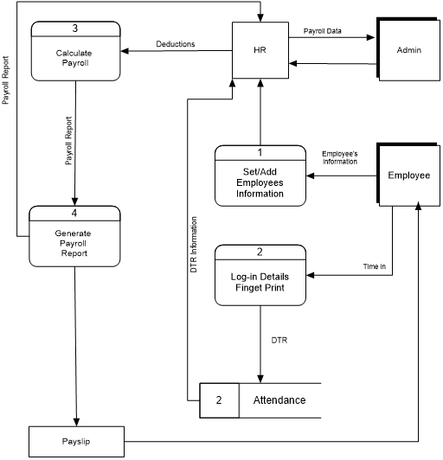

**14­**

**Figure 3.2 Contextual Framework**

**Employee**

**REGISTRATION**

**LOGIN**

**PASSWORD  
USERNAME**

If password and username matched/ if not back to Log-in

**ADMIN**

**Generate Payroll**

**Check Attendance**

**Add Employee**

**Dashboard**

**Update Employee  
Upload Picture**

**Payroll Report**

**Calculate Deductions /  
Print Payslip**

**Payslip**

**Log-out**

**END**

**15­**

**Figure 3.3 Entity Relationship Diagram (ERD)**

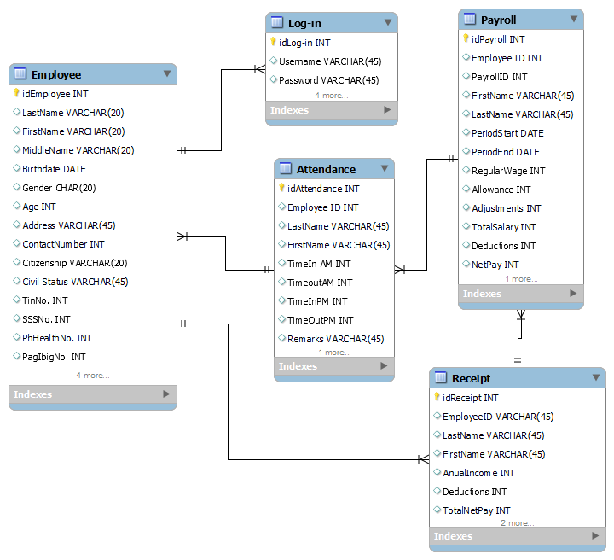

**16­**

**Program Design**

**Figure 3.4 Log-in Form for Admin**

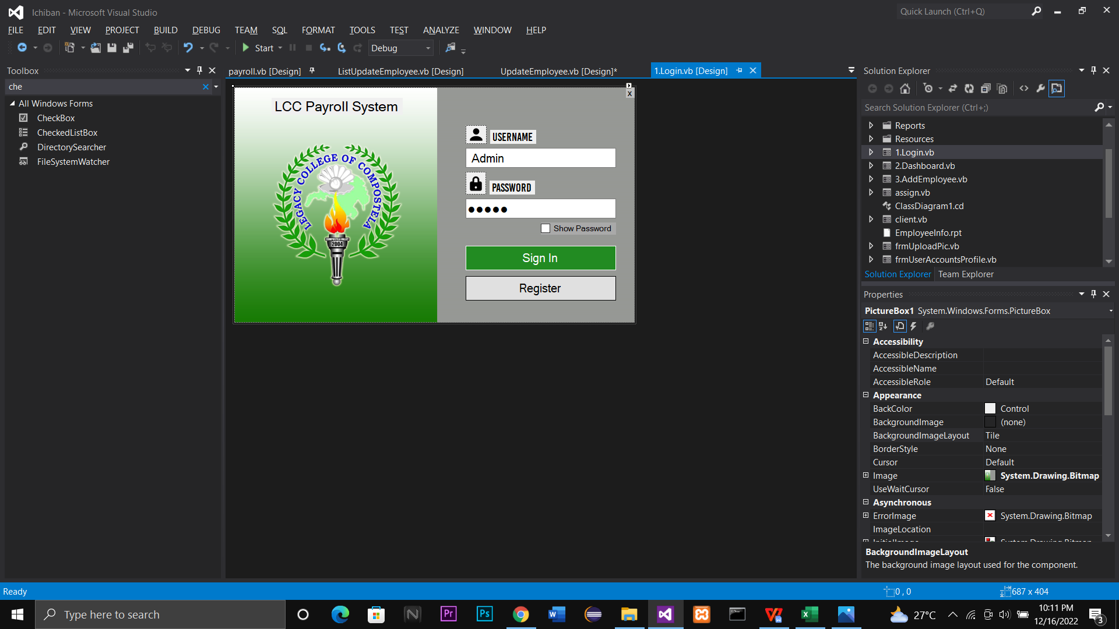

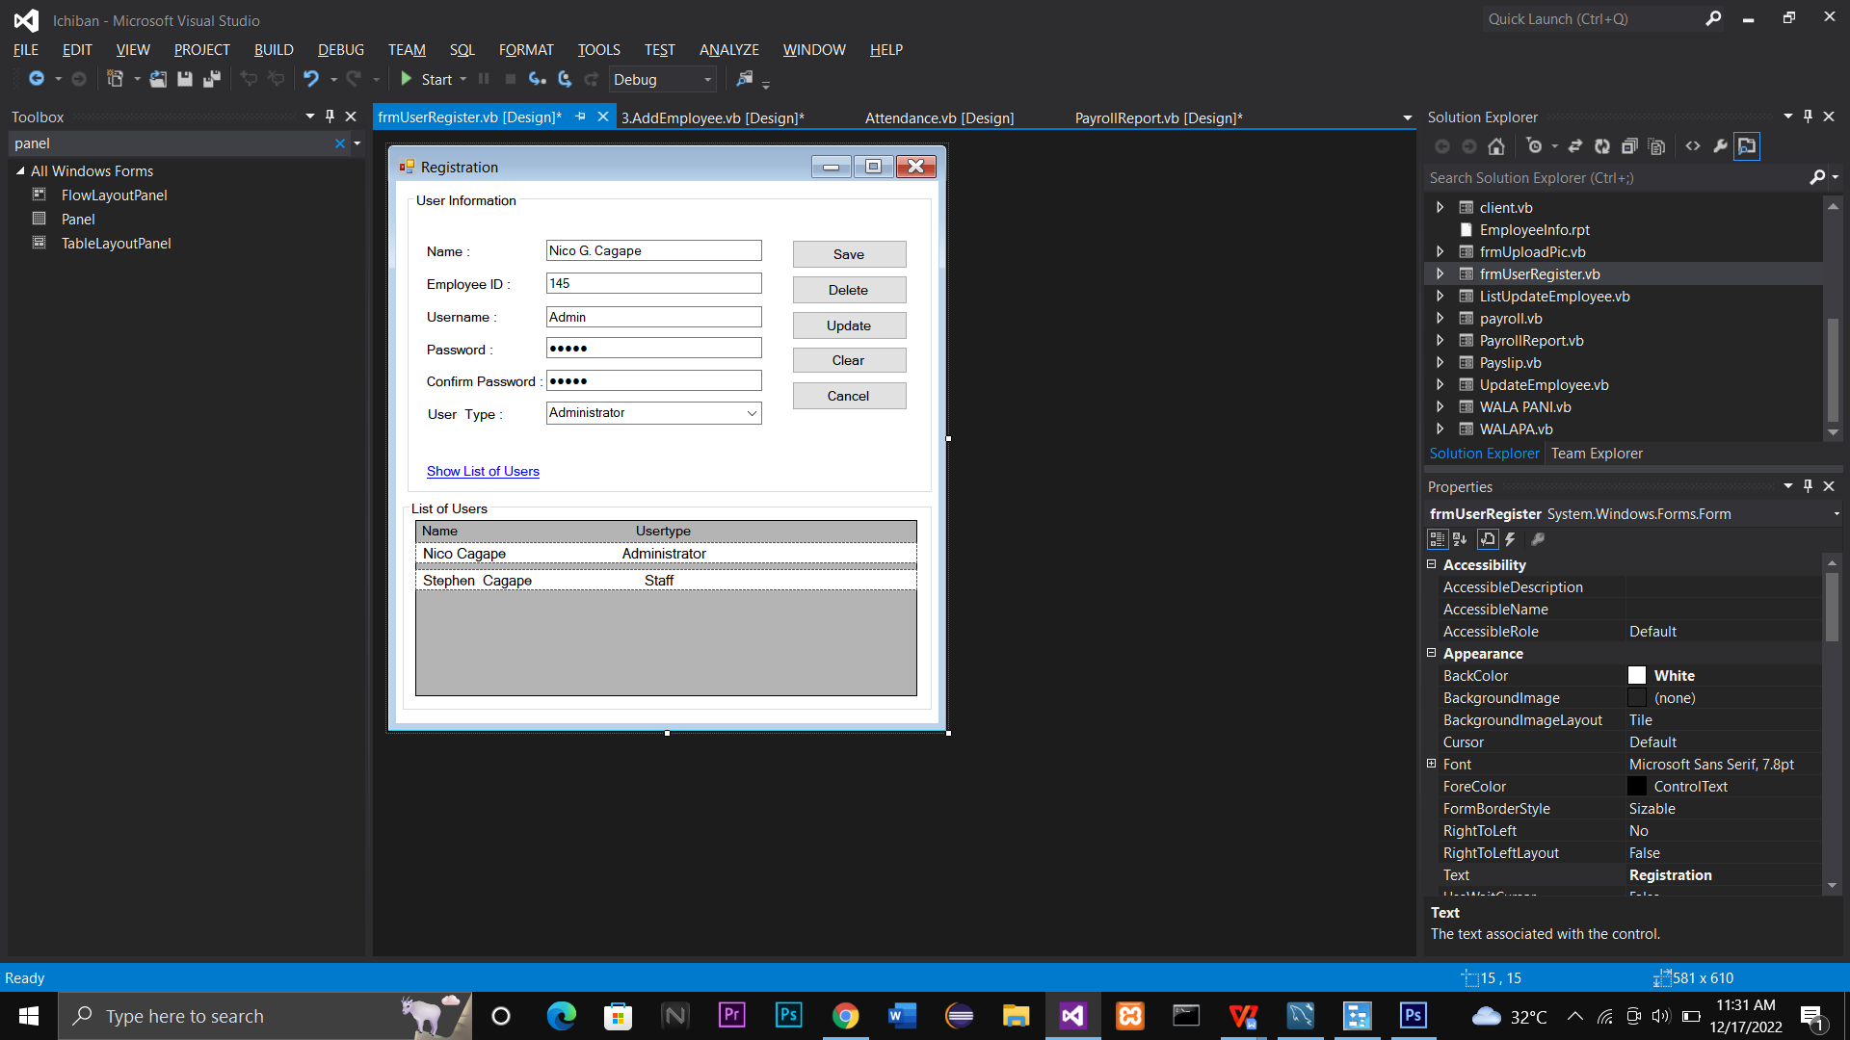**3.5 Register Interface**

**Figure 3.6 Main Form Interface**

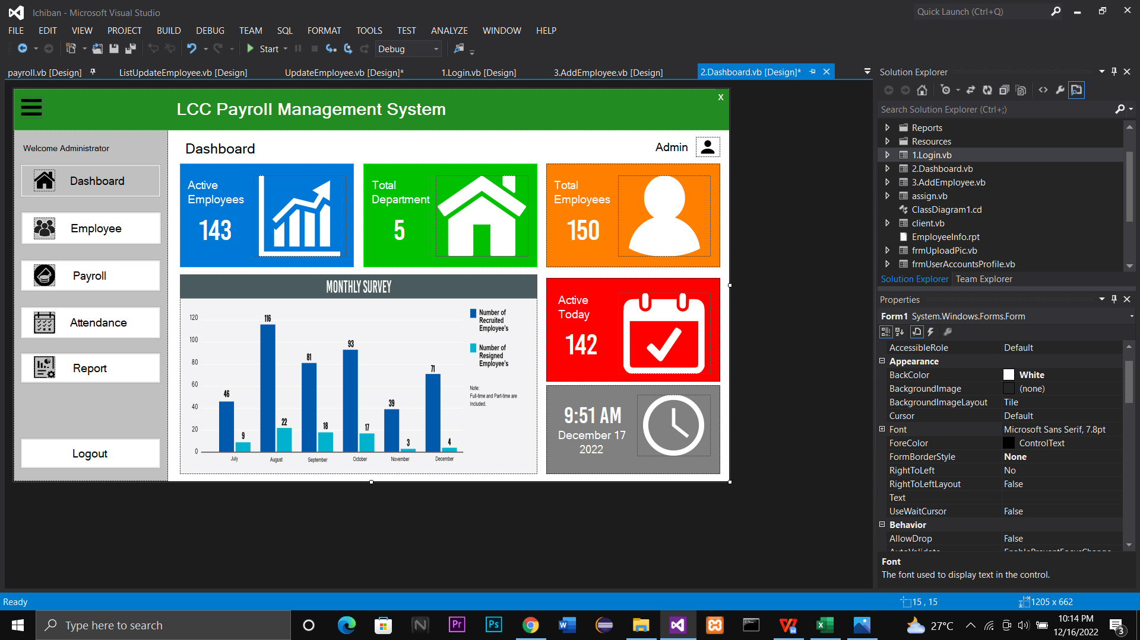

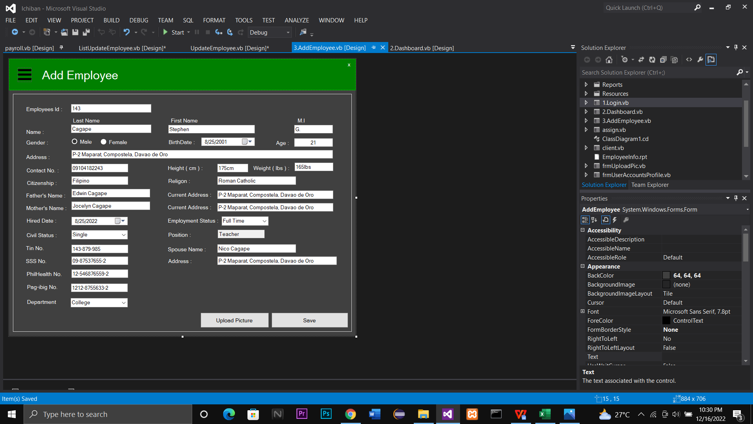**Figure 3.7 Interface of Adding Employee**

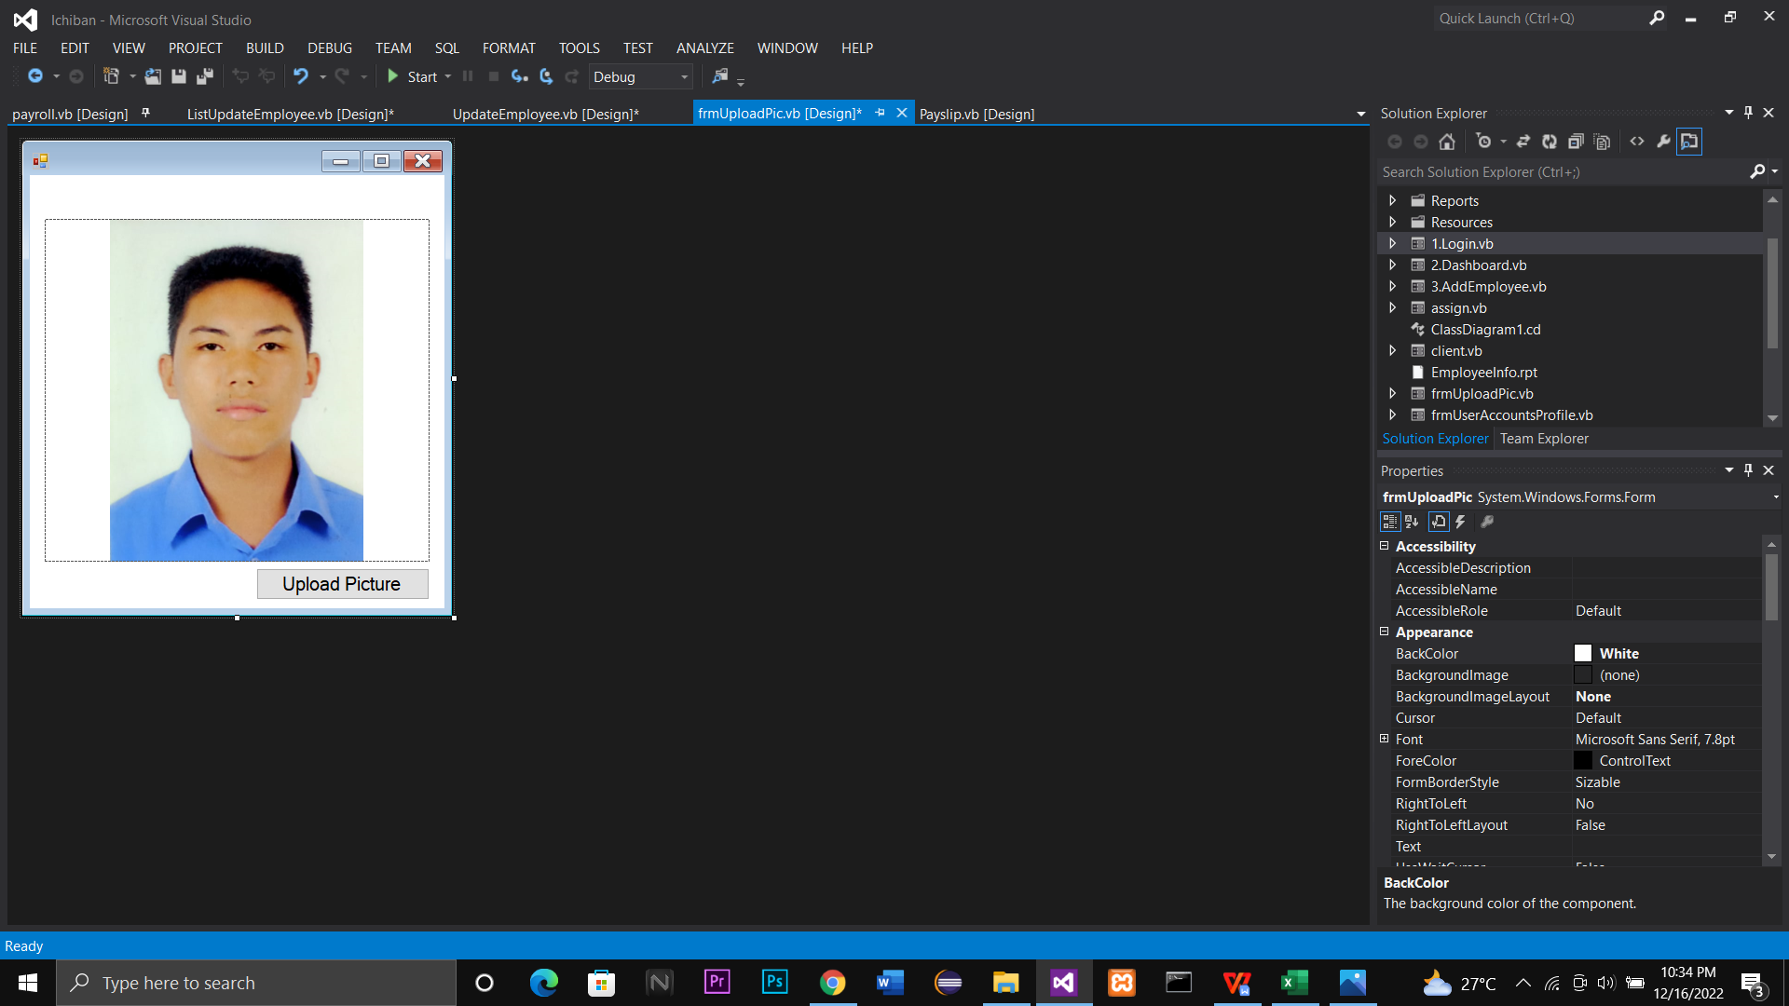**Figure 3.8 Upload Picture**

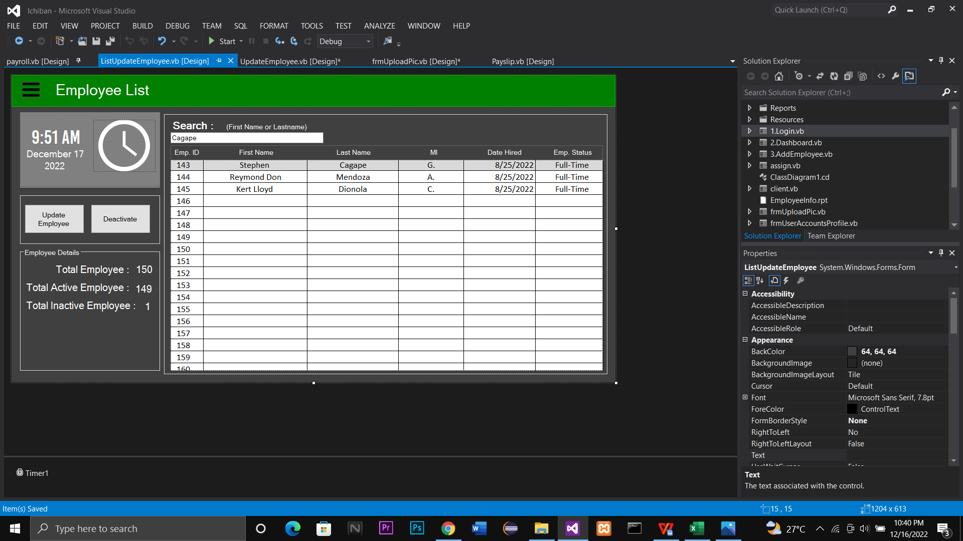**Figure 3.9 List of Added Employee**

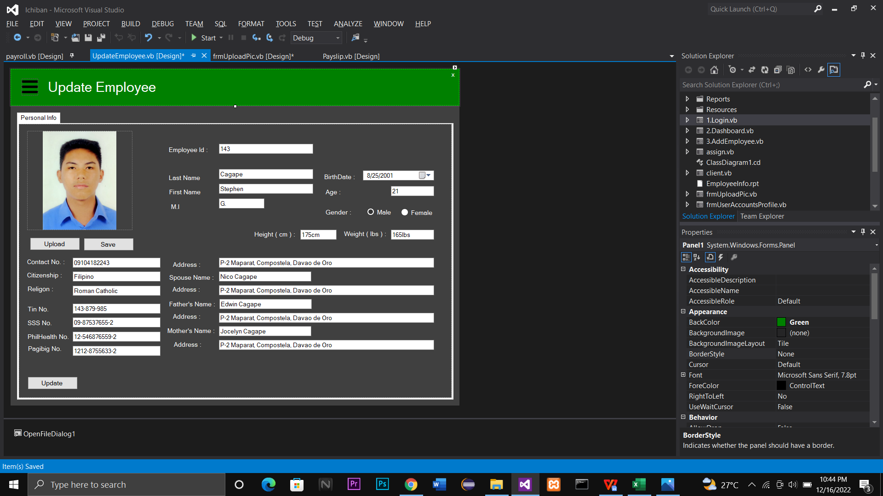**Figure 4.0 Interface of Update Employee**

**Figure 4.1 Interface of Real Time Attendance**

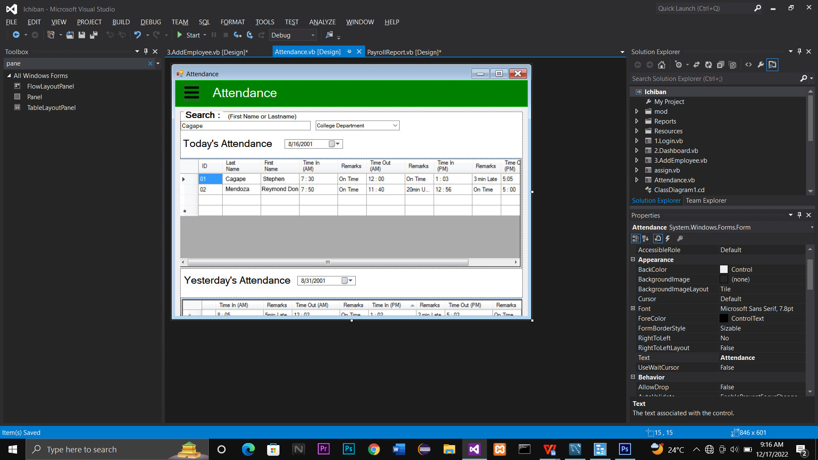

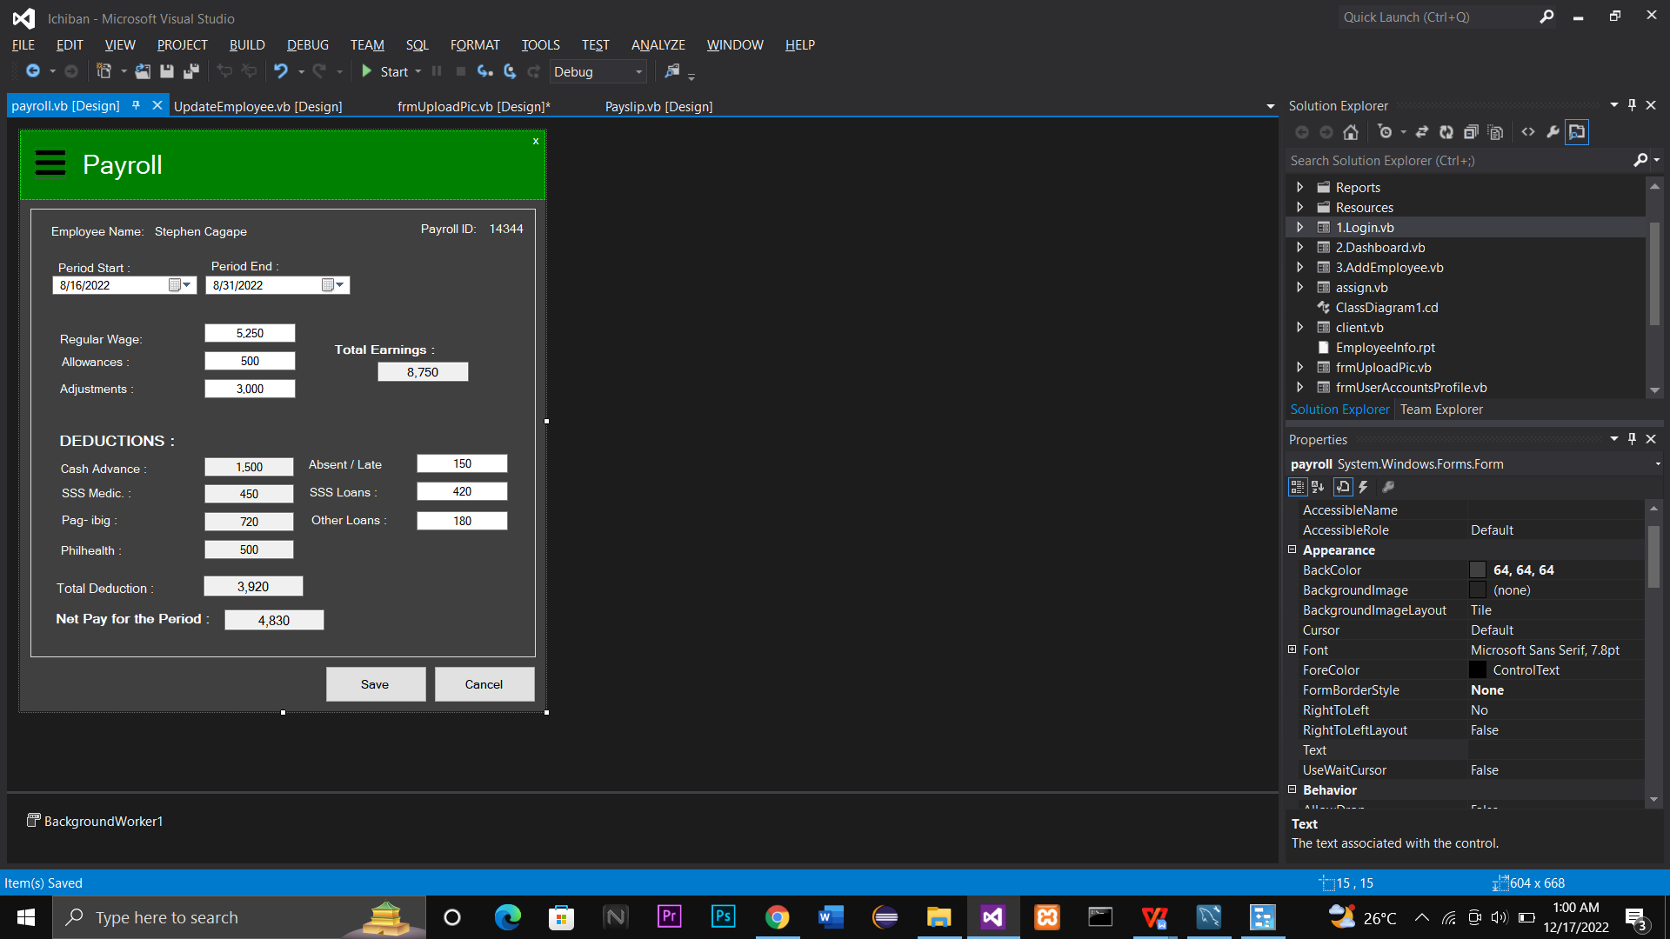**Figure 4.2 Shows the Payroll per Employee**

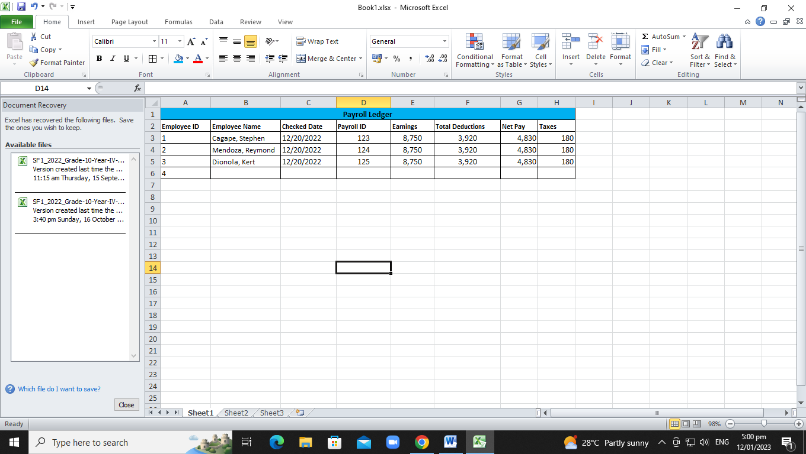

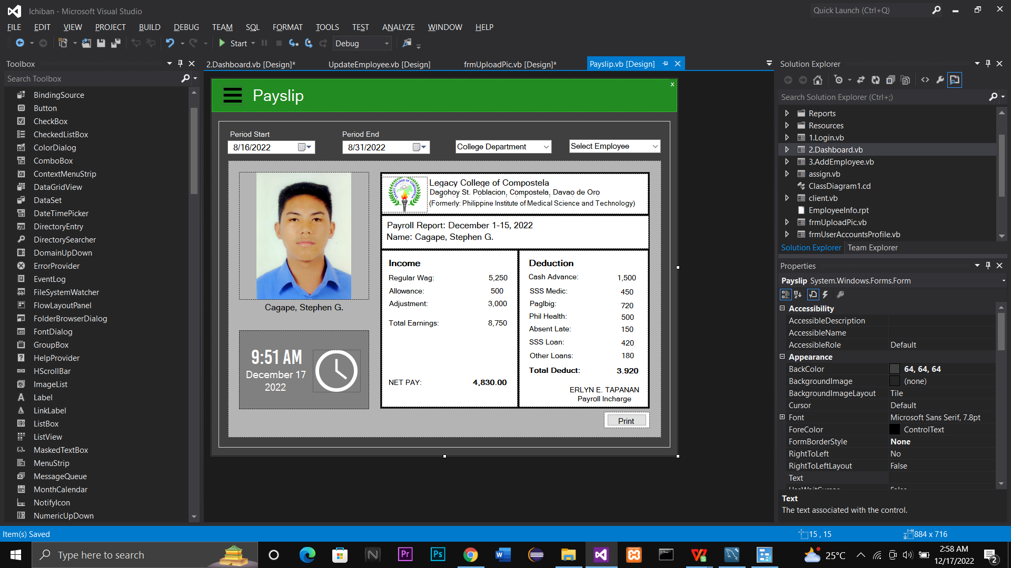**Figure 4.3 Generate Payslip**

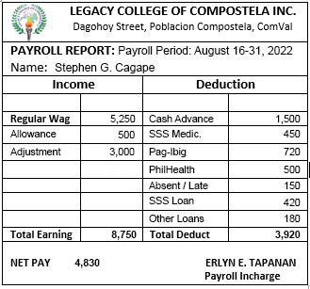**Figure 4.4 Payslip**

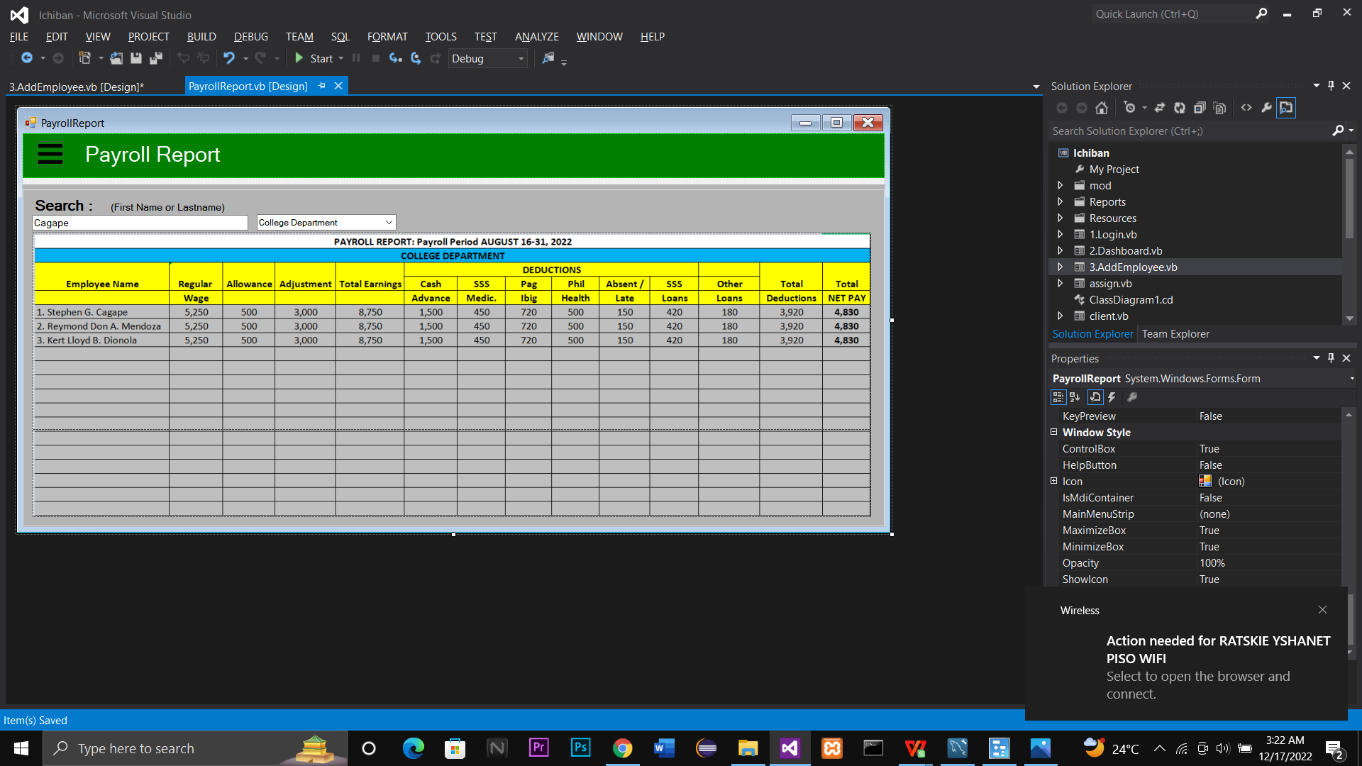**Figure 4.5 Payroll Reports**

**Figure 4.6 Staff Log-in**

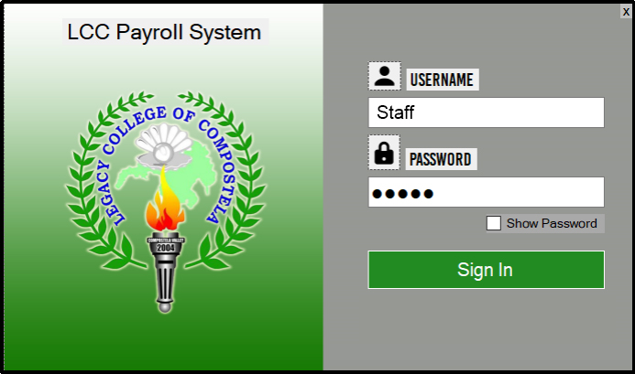

**Figure 4.7 Staff Dashboard**

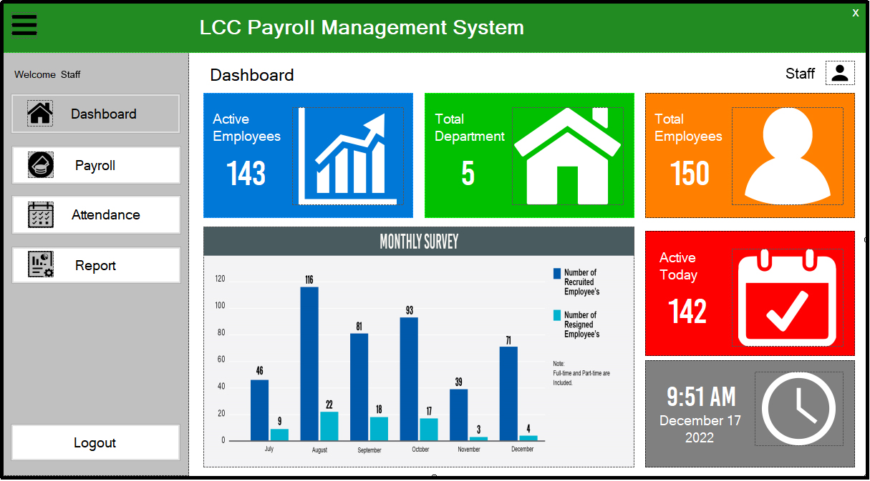

**Figure 4.8 Staff can View Attendance**

**Figure 4.9 Staff can Generate Payroll**



**Figure 5.0 Staff can Generate Payslip**

**Figure 5.1 Printed Payslip**

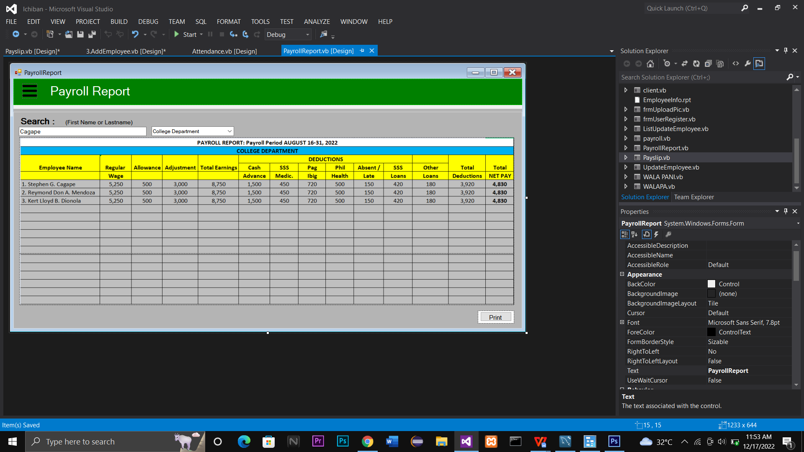**Figure 5.2 Staff can view Payroll Reports**

**Figure 5.3 Printed Payroll Reports**

